Oil China-Your Favorable Business Partner in China

The Only Professional Olive Oil & Edible Oil Exhibition in China & Asia
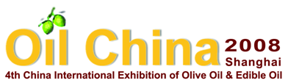
May 15th – 17th, 2008
Shanghai Ever Bright Exhibition Center

Approved by: | China Council for the Promotion of International Trade (CCPIT)  China Chamber of International Commerce (CCOIC)
Organizer: | CCPIT Specialized Sub-Council of Agriculture
Co-Organizer: | Beijing Regalland Convention & Exhibition Co., Ltd.
Supporters: | Chinese Cereals and Oils Association (CCOA), Oil & Fat Association  Chinese Academy of Forestry  China Olive and Olive Oil Association, Preparation Committee  China Olive Oil Club  China Cereal & Oil Market Newspaper  China Oil & Fat
Official Website: | www.eoliveoil.com www.oliveoillife.com

Deadline: March 10, 2008, after the date in the waiting list

Chinese Olive Oil Market

Chinese market, especially Chinese olive oil market, is becoming the focus of attention all over the world and China’s market is fully open to the world. Though there are some the adaptable regions of olive growing in the western China, but olive in China cannot be planted widely for lack of the planting technology, olive seeds, fund, technicians and many other reasons. At present the olive planting area accounts for 20,000 hectare and those olives trees are young and little olives are fructiferous and in autumn, so at present more than 100-brand olive oil appear in Chinese olive oil market, which nearly 100% import from Spain, Greece, Italy, Turkey, Tunis, Portugal, Jordan, Australia and so on. The main consumption cities of olive oil are Beijing, Shanghai, Shenzhen, Guangzhou, Tianjin and other large and middle cities. According to the following graph, since 2001 the average proportion of import olive oil has been keeping the increases over 70% per year. With the same rate till 2008 that Beijing will hold Olympic Games, the amount of import olive oil will reach 20000 tons and till to 2010 that World Expo will be held in Shanghai it will be over 60,000 tons. China is the booming Market for olive oil and the scale will be larger. In a word, it is right time to expand your business in China.

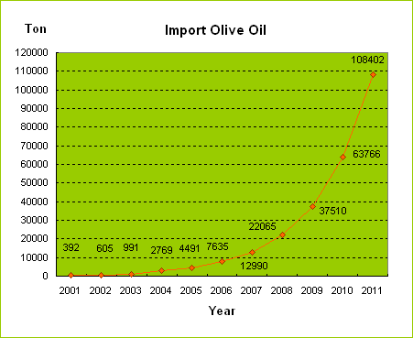

Oil China 2007

Since 1st Oil China 2005, Oil China, as the only, professional international exhibition of olive oil and edible oil in China, Oil China offers the most direct and efficient business site for between the producers, exporters with the importers, traders, dealers, and agents to meet each other, achieve the cooperation and expand the influence of olive oil brands, and also would make consumers learn more about the knowledge of olive oil and build up the favorable consumption concept of olive oil. 3rd Oil China 2007 has been held successfully from April 16 to 18 in Beijing. Over 120 companies that are from Spain, Italy, Greece, Turkey, Jordan, Syria, Portugal, Tunisia, Germany, Australia, Switzerland, Israel, China, Hong Kong have participated in this exhibition, especially, Spain, Italy, Greece and Jordan have appeared in this exhibition as National Pavilions,

Feedback from the visitors

According to the data from the specialized statistic company, 5500 visitors have attended Oil China 2007. Besides 97% visitors from China, the other visitors of Oil China 2007 were from Korea, Japan, Germany, Malaysia, Israel, Singapore, Spain, Turkey, Tunis and Argentina. From the following graphs you will find the business and purpose of the visitors and learn more about d Chinese olive oil market.

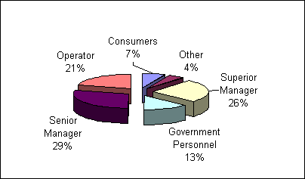
Above senior manager: 54%
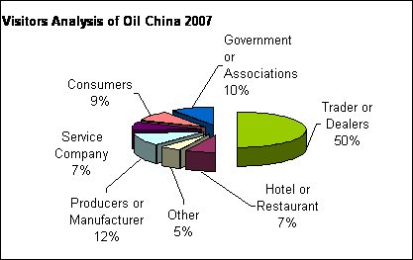
Traders or dealers: 50%
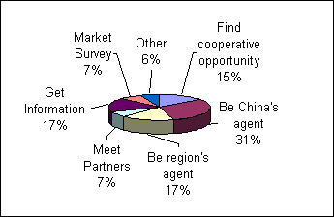
Above 65% visitors’ aim: to be agents and get information

Feedback from the exhibitors

From the feedback of the exhibitors, 90% exhibitors thought that 3rd Oil China 2007 is professional and provided full service; 82% exhibitors are satisfied with Oil China 2007 because that they have met more than 50 potential partners and could spread their brands of olive oil. 90% exhibitors will continue to participate in Oil China 2008.

Oil China 2008 - Positive Plan

- Focus: Focus on displaying products of olive oil and the culture, nutrition and function of olive oil
- Target group: Traders, Importers, dealers, reporters, potential consumers
- Layout: Country Pavilion, Culture Zone and Olive Oil Tasting Zone
- Vital Activities:
  - Country Day (according to some Country’s request)
  - 4th China International Olive Oil & Edible Oil Forum
  - 3rd China International Olive Oil Competition
  - International Olive Oil Gourmet Festival
  - 2008 Chinese Importers’ Training Project about Olive Oil Tasting
  - Chinese Olive Projects Investment Conference
  - Buyers and Sellers Meeting (BSM)

- Promotion Plan
  - To mail and distribute over 100000 visitors tickets
  - To hold some nonscheduled press conference about the exhibition and industry;
  - Through some public and professional media to promote Oil China and the knowledge of olive oil, for example, Xin Hua News Agency, China Oil & Fat, China Cereal & Oil Market Newspaper, Cereal & Oil Technology, www.google.com, China food business Website, China Oil & Fat Information Website, China Business Newspaper, China Consumption Daily, China Consumer Day, China Quality Daily, Xin Min Evening Paper, Guangzhou Daily, Shenzhen Dialy and so on.
  - Chinese Cereals and Oils Association, China Vegetable Oil Association, China Olive Oil Club, Trading Promotion Center of the Ministry of Agriculture and other related associations and organization will invite their members to visit Oil China 2008。
  - To hold 2008 National Olive Oil Knowledge Contest will be helpful to invite more trading visitors.

2008 Exhibition Information

1. Date & Venue:
- Date: May 15th to 17th, 2008
- Venue: Shanghai Ever Bright Exhibition Center
- Add: No.66 Cao Bao Road, Xuhui District, Shanghai 200235 China

2. Scope of Exhibits
- Olive oil, virgin and extra virgin olive oil, organic and DOP olive oil, olive products, olive oil by products (cosmetics), technology
- Other special type edible oil, camellia oil, grape seed oil, safflower seed oil, nucleolus oil, almond oil, pumpkin oil, garlic oil and so on.
- Soybean oil, corn oil, colza oil, peanut oil, cottonseed oil, concoction oil and salad oil
- Edible oil by new products, new technology, equipment
- Publication, services
- Other related products like wine, vinegar and so on.

3. Space Rental （Step 1:choose your space; Step 2:choose your fitted equipment）
A. Raw space rental (minimum 9 square meters)
- 1 side open (min 9 sq.m.) Euro 220 per sq.m.
- 2 sides open (min 12 sq.m.) Euro 240 per sq.m.
- 3 sides open (from 18 sq.m. to 54sq.m.) Euro 280 per sq.m.
- 4 sides open (from 36sq.m. to 72 sq.m.) Euro 360 per sq.m.
- 3 or 4 sides open (73 sq.m. or more) Euro 260 per sq.m.

B. Stand equipment (not inclusive of raw space rental cost, see details on annex 1)
- Basic Standard Package (minimum: 9 sq.m.): Euro 40 per sq.m.
- Senior Standard Package (minimum: 9 sq.m.): Euro 80 per sq.m.
- Luxury Standard Package (minimum: 12 sq.m.): Euro 100 per sq.m.

Remarks:
- Bookings confirmed prior to October 30, 2007 will be granted 10% discount of the raw space rental or one 4C page of the official catalogue (the price of full page 4C is Euro 1000) for free;
- If you need special design & decoration of your space or standard booth, please directly contact us.

4. Other Related Exhibition:
- 2008 China International Exhibition of Technology & Equipment Olive Oil & Edible Oil (OilTech China 2008)

5. 2008 3rd China International Olive Oil Competition
This competition will be held during Oil China 2008 and the result will be public during Oil China 2008.
The relevant Fee as follows:
- The Participation basic fee: EURO 220 (include VAT) per participant
- The Handling fee: EURO 200 (include VAT) per extra virgin olive oil
Remarks: The exhibitors of Oil China 2008 will get a 50% discount of the participation basic fee;

6. Advertisement Opportunity
- Official Catalogue (the size of 210mm x 140mm)
  - Bookmark with string (150mm x 50mm) EURO 1000
  - Full 4C page (210mm x 140mm) EURO 1000
  - Inside Double 4C pages (280mm x 210mm) EURO 1800
  - Inside front cover (210mm x 140mm) EURO 1600
  - 1st right hand page (210mm x 140mm) EURO 1800
  - Inside back cover (210mm x 140mm) EURO 1500
  - Outside back cover (210mm x 140mm) EURO 2000

- Ticket and Hand Bag
- Back Cover of Ticket (210mm x 95mm) EURO 1000 per 20000 tickets (the total of tickets, 100000)
- Back Cover of Bag (297mm x 350mm) EURO 1000 per 2000 bags (the total of bags, 6000)

- The ad. on the exhibition hall will be found on the Exhibitor Service Manual.

7. Product Press Conference
If you wish to promote your product or your company through the press conference, we will provide the following service for you:

- 50-100 meeting room;
- One projection set
- One microphone and sound box
- 50-100 related visitors, reporters
- 1 hour per conference

The service fee per conference is EURO 1000 and will be floating in accordance with the exhibitor’s concrete request. Before February 1, 2008 booking press conference will be accepted.
Enquiry, please Contact: Mr. Robert Woo
Beijing Regalland Convention & Exhibition Co., Ltd.
Add: Room No.438 Jin Ou Building, An Zhen Li,
Chao Yang District, Beijing 100029 China
Tel:0086 10 64416542, 64414996 Fax:0086 10 64412631
Website: www.eoliveoil.com E-mail: regalland@regalland.com

Annex-1

(Non contractual pictures)
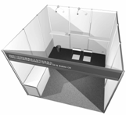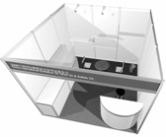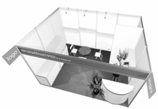
Basic Standard Package
Senior Standard Package
Luxury Standard Package

Item | Basic Standard Package | Senior Standard Package | Luxury Standard Package
Price | Euro 40 per sq.m. | Euro 80 per sq.m. | Euro 100 per sq.m.
Minimum surface | 9 sq.m. | 9 sq.m. | 12 sq.m.
Partition walls | Yes | Yes | Yes
Carpet | Yes | Yes | Yes
Fascia Name (1) | 1 | 1 | 1
Company signage | • | • | 1 panel
Lights (2) | 2 lamp lights | 2 spotlight | 3 spotlight
Electricity and power plug | 1 x 13 amp | 1 x 13 amp | 1 x 13 amp
Exhibit Table | 1 | 1 | 1
Round table | • | 1 | 1
Chairs (3) | 2 | 3 | 3
Information counter | • | 1 | 1
Bar stool | • | 1 | 1
Waste paper basket | 1 | 1 | 1
Flat shelves (4) | 4 lm | 4 lm | 4 lm
Tall showcase (5) | • | 1 | 1
Lockable storage | • | • | 1 (1m x 1m)
Potted plants (6) | • | • | 2
Stand cleaning | 3 days | 3 days | 3 days

Remark: (1) 1 fascia names per 1 open side;(2) Additional 1 light per 3 sqm; (3) Additional 1 chair pre 3 sqm; (4) Additional 1 shelf per 3 sqm;(5) Additional 1 showcase per 6 sqm; (6) Additional 1 potted plant per 6 sqm

