The prize logo stickers on the bottles like the following photo, which will be helpful for you to show your olive oils with the corresponding prizes.

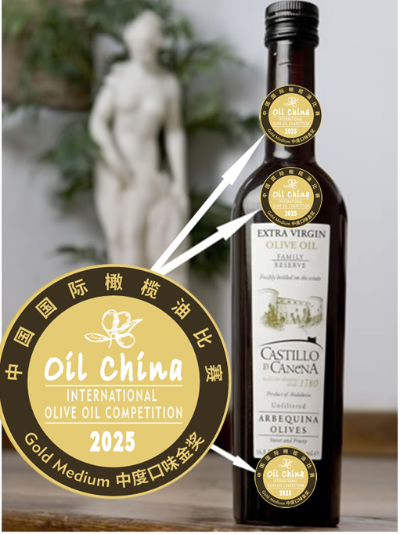 ‘

The Shape of finished prize logo stickers
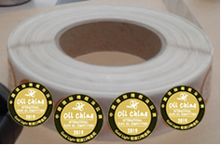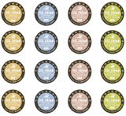
Left-handed or right-handed scroll sticker paper

20th Oil China Competition 2025
Prize Logo Stickers Order Form

According to the rule of Oil China Competition 2025, the winners will have the privilege to order the quite quantities of prize logo stickers from the organizer, and the prize logo stickers may be pasted on the bottles of your olive oils that are awarded in 2025. The shape of finished prize logo stickers is scroll or paper. If you want to order the stickers for your awarded olive oils, please fill this form and then send to the organizer:

The 2025 Prize Logo Stickers (we may provide the finished stickers for you)
No. | Item | Unit Price | I | M | L | O | Number | amount
1 | Gold Prize Logo Stickers Set | € 65 or $ 68 per set
2 | Silver Prize Logo Stickers Set | € 65 or $ 68 per set
3 | Bronze Prize Logo Stickers Set | € 65 or $ 68 per set
4 | Grand Mention Prize Logo Stickers Set | € 65 or $ 68 per set
 | Total Cost
I=Intense; M=Medium; L= Light; O=Organic (tick off √)
Note:
- Each SET contains 1,000 individual prize logo stickers.
- The shape of finished prize logo stickers: ( ) left-handed scroll ( ) right-handed scroll ( ) paper
- The above cost does not contain the Freight Charge, so please tick off √ as follows:
( ) The stickers will be sent to your agent or representatives in China, the delivery is FREE
( ) If you have the account of the carriers like DHL,TNT or other carriers, please write down your account number: (□DHL □TNT □UPS □FEDEX □ other: )
( ) The stickers will be sent to you directly by the organizer, you should additionally pay the freight charge that is euro 80 (1-3 sets) or euro 120 (4-5 sets) or euro 180 (5-10 sets) or more than 200 (over 10 sets).

When we receive your order form, we shall send you the invoice and then you may make the payment by Wechat Pay, Paypal or Credit Card or bank transfer.

Company Name:
Address:
Name of Person In Charge: |  | DATE:
Tel: | E-mail: | DATE:
Please send the above form by email To: Regalland  Contact: Ms. Jenny Yang  E-mail: info@eoliveoil.com Tel:0086 10 64416542 |  | SIGNATURE:

